1. **Introduction/Background**
   1. **Centrality**

The most important vertices of the graph are identified by centrality scores. There are many ways of calculating centrality. Each vertex is assigned a value based on the type of centrality used. Various types of centralites are as follows:

1. Betwenness Centrality
2. Degree Centrality
3. Closeness Centrality
4. Katz Centrality

The following centralities has been considered for the project

* + 1. **Degree Centrality:**

This centrality defines the number of edges incident upon a vertex. Indegree and Outdegree can be used. Number of edges pointing towards a node is called Indegree and number of edges pointing to other nodes is called outdegree.

Consider a graph G(V, E), with V as the vertices and E as the edges. The centrality can be calculated as

CD = deg(V)

O(V2) time is taken for the calculation of degree centrality in a dense adjacency matrix whereas O(E) time is taken in a sparse matrix.

Applications:

1. The node which has highest risk of catching the disease can be found.
2. Popularity can be gauged using Indegree whereas gregariousness can be gauged using Outdegree.
   * 1. **Closeness Centrality:**

This centrality is defined as reciprocal of sum of length of shortest paths between the node to other nodes. Bavelas defined the centrality as

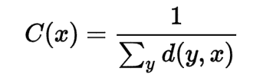

Websites with outgoing link can have high closeness centrality whereas it might be low with incoming links.

* + 1. **Betweeness Centrality:**

This is defined by the number of shortest paths that pass through the vertex.

Betweenness Centrality is given by:

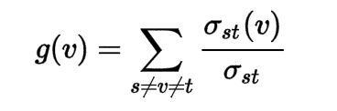

where,

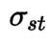 {\displaystyle \sigma _{st}}is the total number of shortest paths from node {\displaystyle s}s to node t

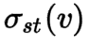  is the number of paths that pass through v

So, the shortest paths have to be found and calculated based on the distance.  [Floyd–Warshall algorithm](https://en.wikipedia.org/wiki/Floyd%E2%80%93Warshall_algorithm) will take O(V3) time for finding the shortest paths. On a sparse graph, Johnson and Brandes Algorithm will take O(V2 log V + VE). For unweighted graphs, Brandes Algorithm will take O(VE) time for calculating the centrality.

{\displaystyle t}t

tt t

Applications:

1. In a telephone network, a node with high Betweenness Centrality will have higher importance as more information will pass through it.
   1. **Applications of Centrality in Genral:**
2. In a social network, the most important people can be identified.
3. Find who can be the gossipmonger among the list of friends.
4. The famous celebrity among a list of celebrities can be found.
5. The source cell responsible for the spread of the disease can be found.
6. The substation which can face the most load in a telephone network can be found.
7. Patterns of Social Relationships can be found.
8. **Algorithm**

* Brandes Algorithm[6] has been considered instead of Floyd-Warshall Algorithm as the complexity for finding the shortest distance is less. The algorithm is as follows:

1. **RESULTS**

Home page of the project using which the path of the file can be given and the following centralities can be calculated.

1. Between Centrality
2. Degree Centrality
3. Closeness Centrality
4. Katz Centrality

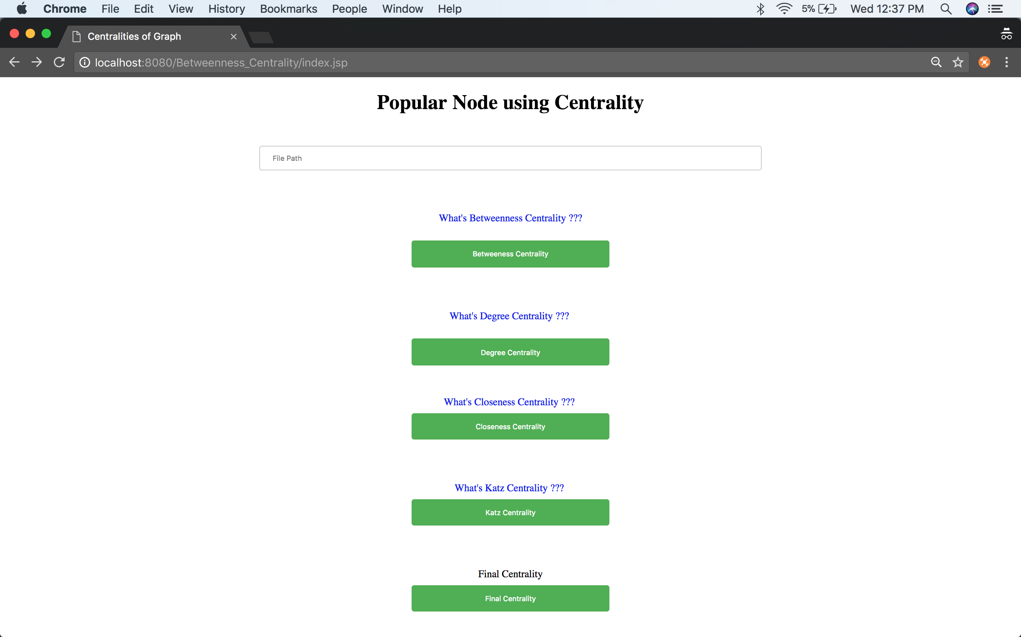

Betweenness Centrality :

* For 6 nodes and 7 edge

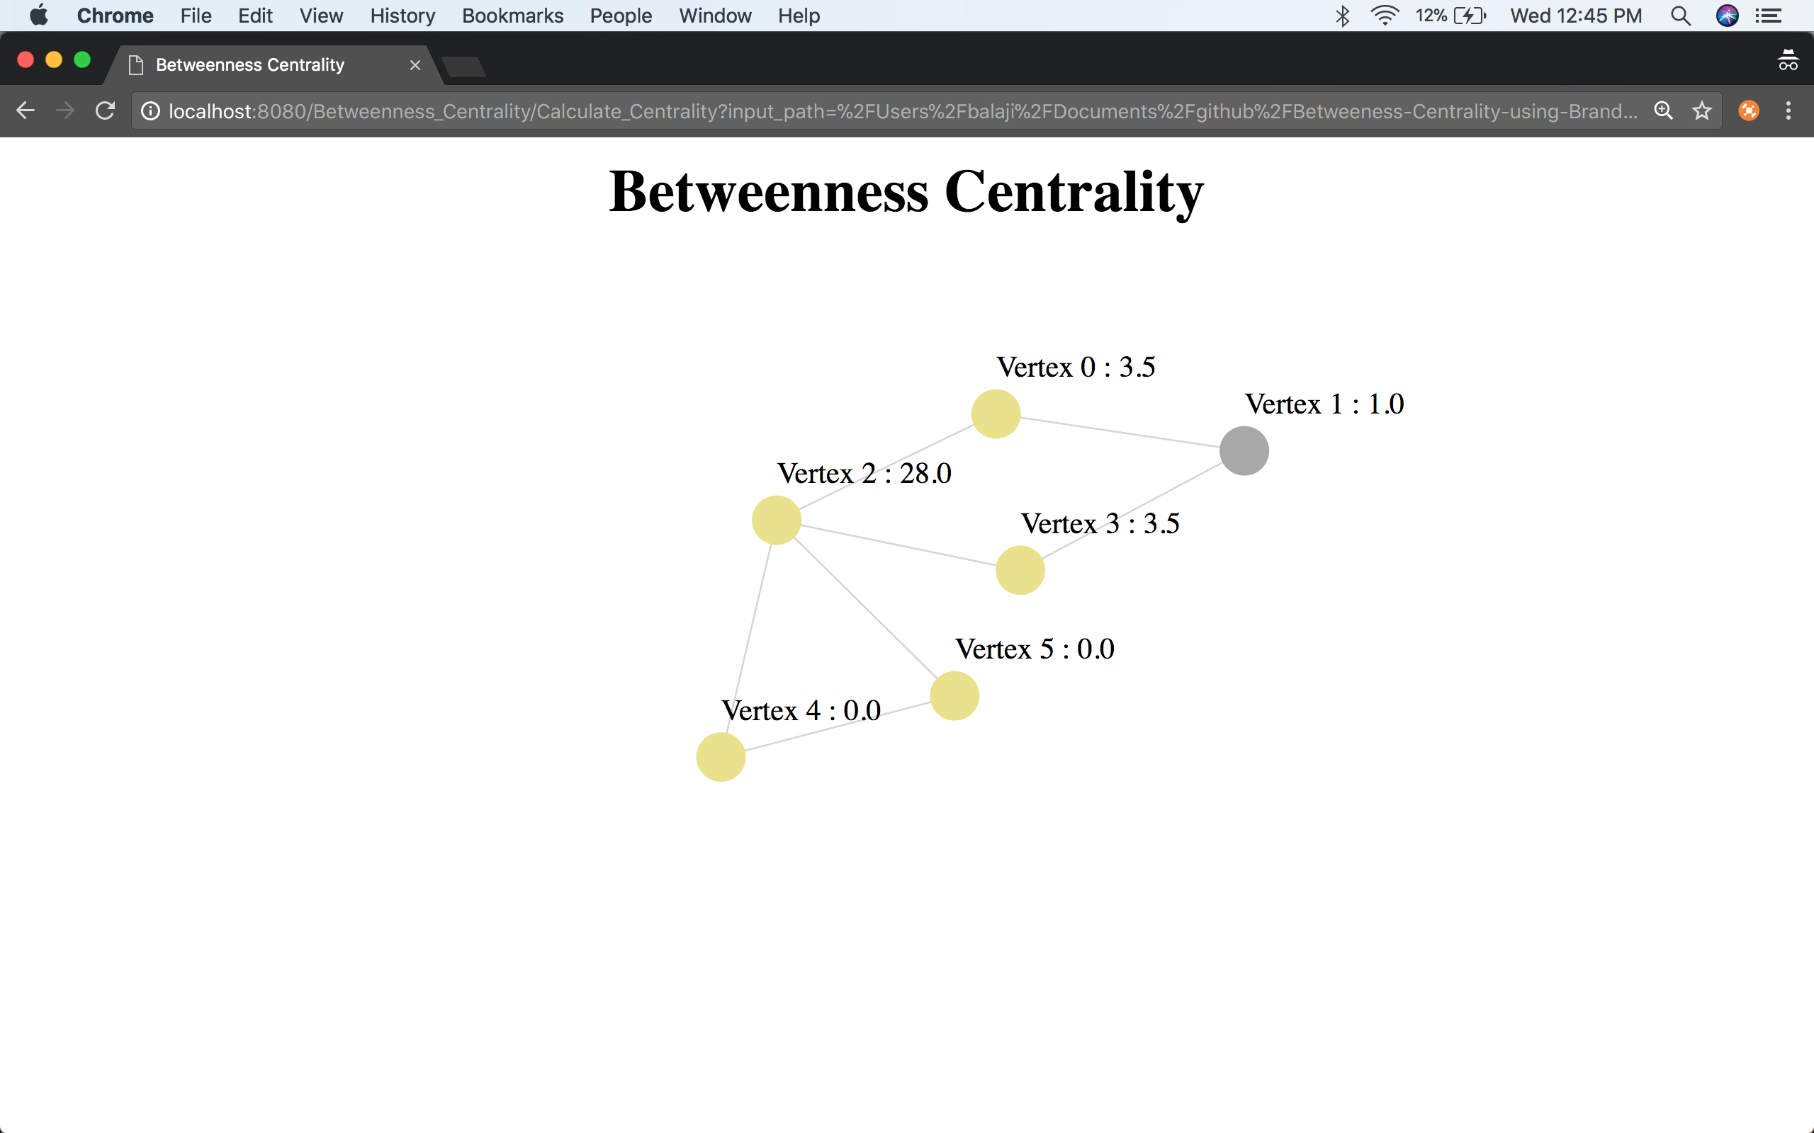

* For 880 nodes and 1000 edges

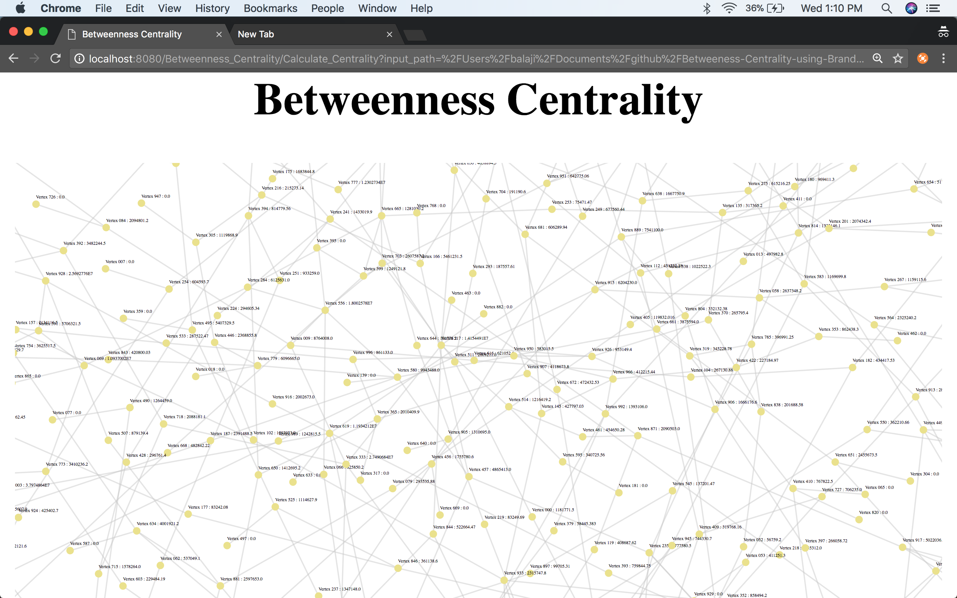

Degree Centrality

* For 6 nodes and 7 edges

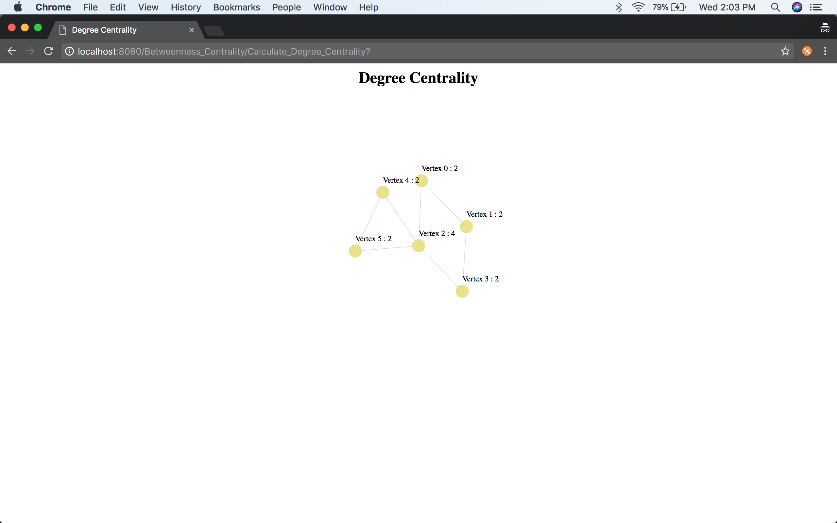

* For 880 nodes and 1000 edges

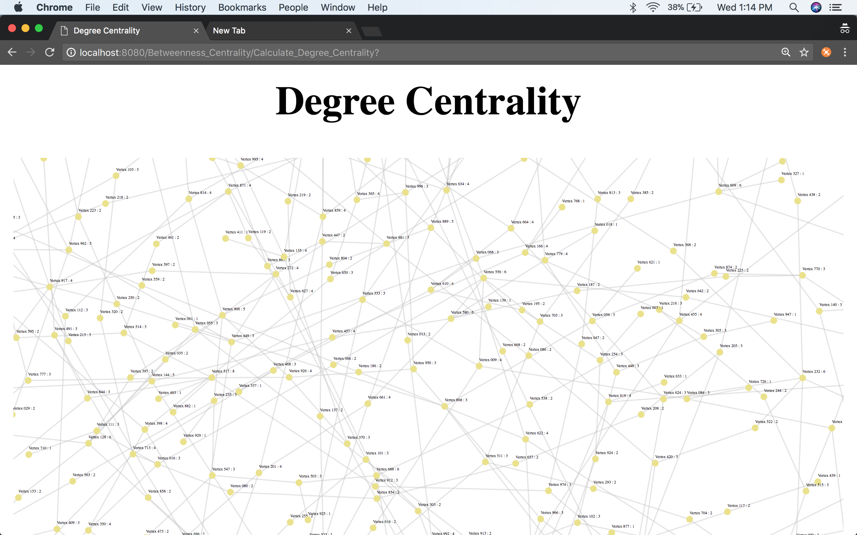

Closeness Centrality

* For 6 nodes

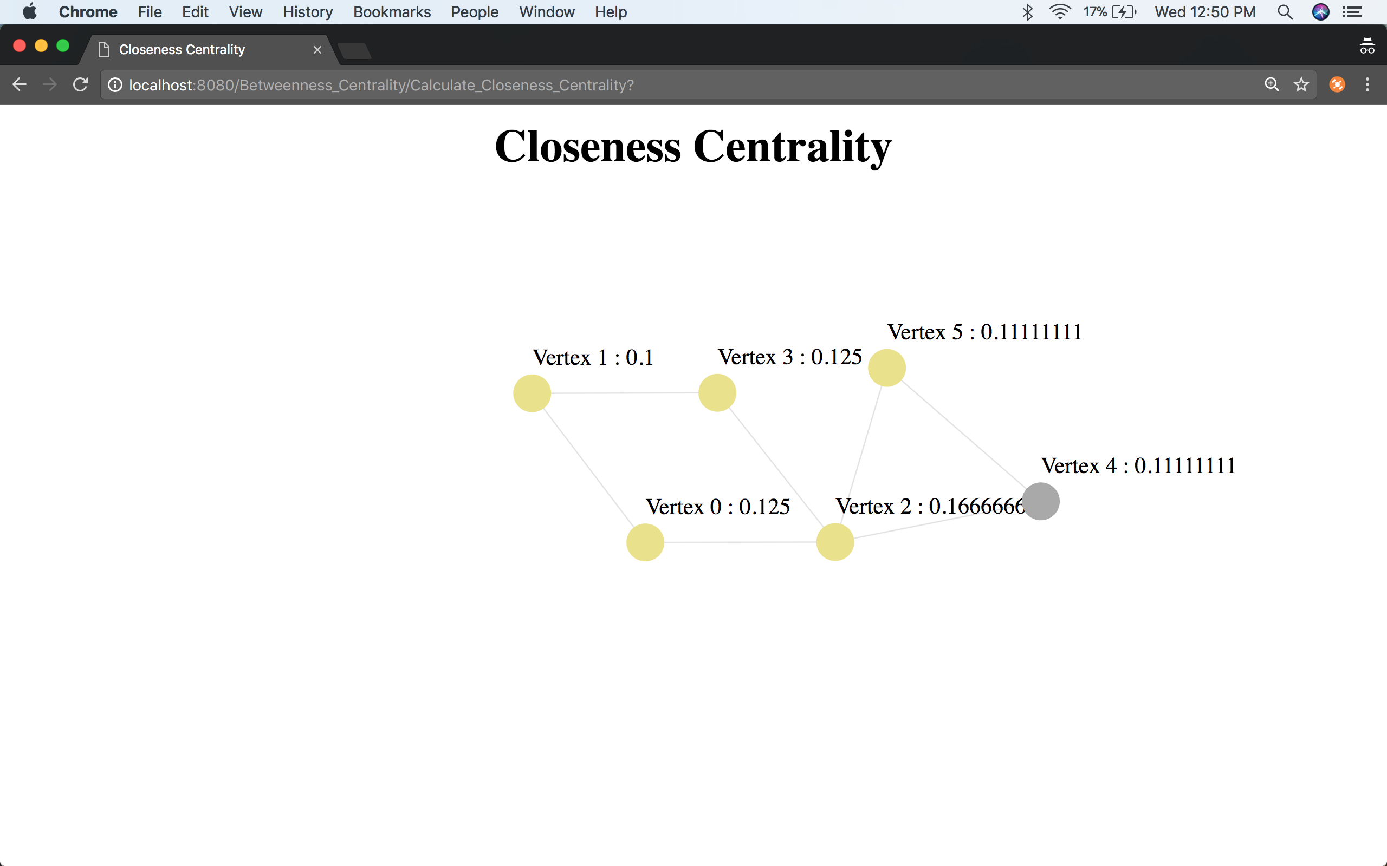

* For 880 nodes and 1000 edges

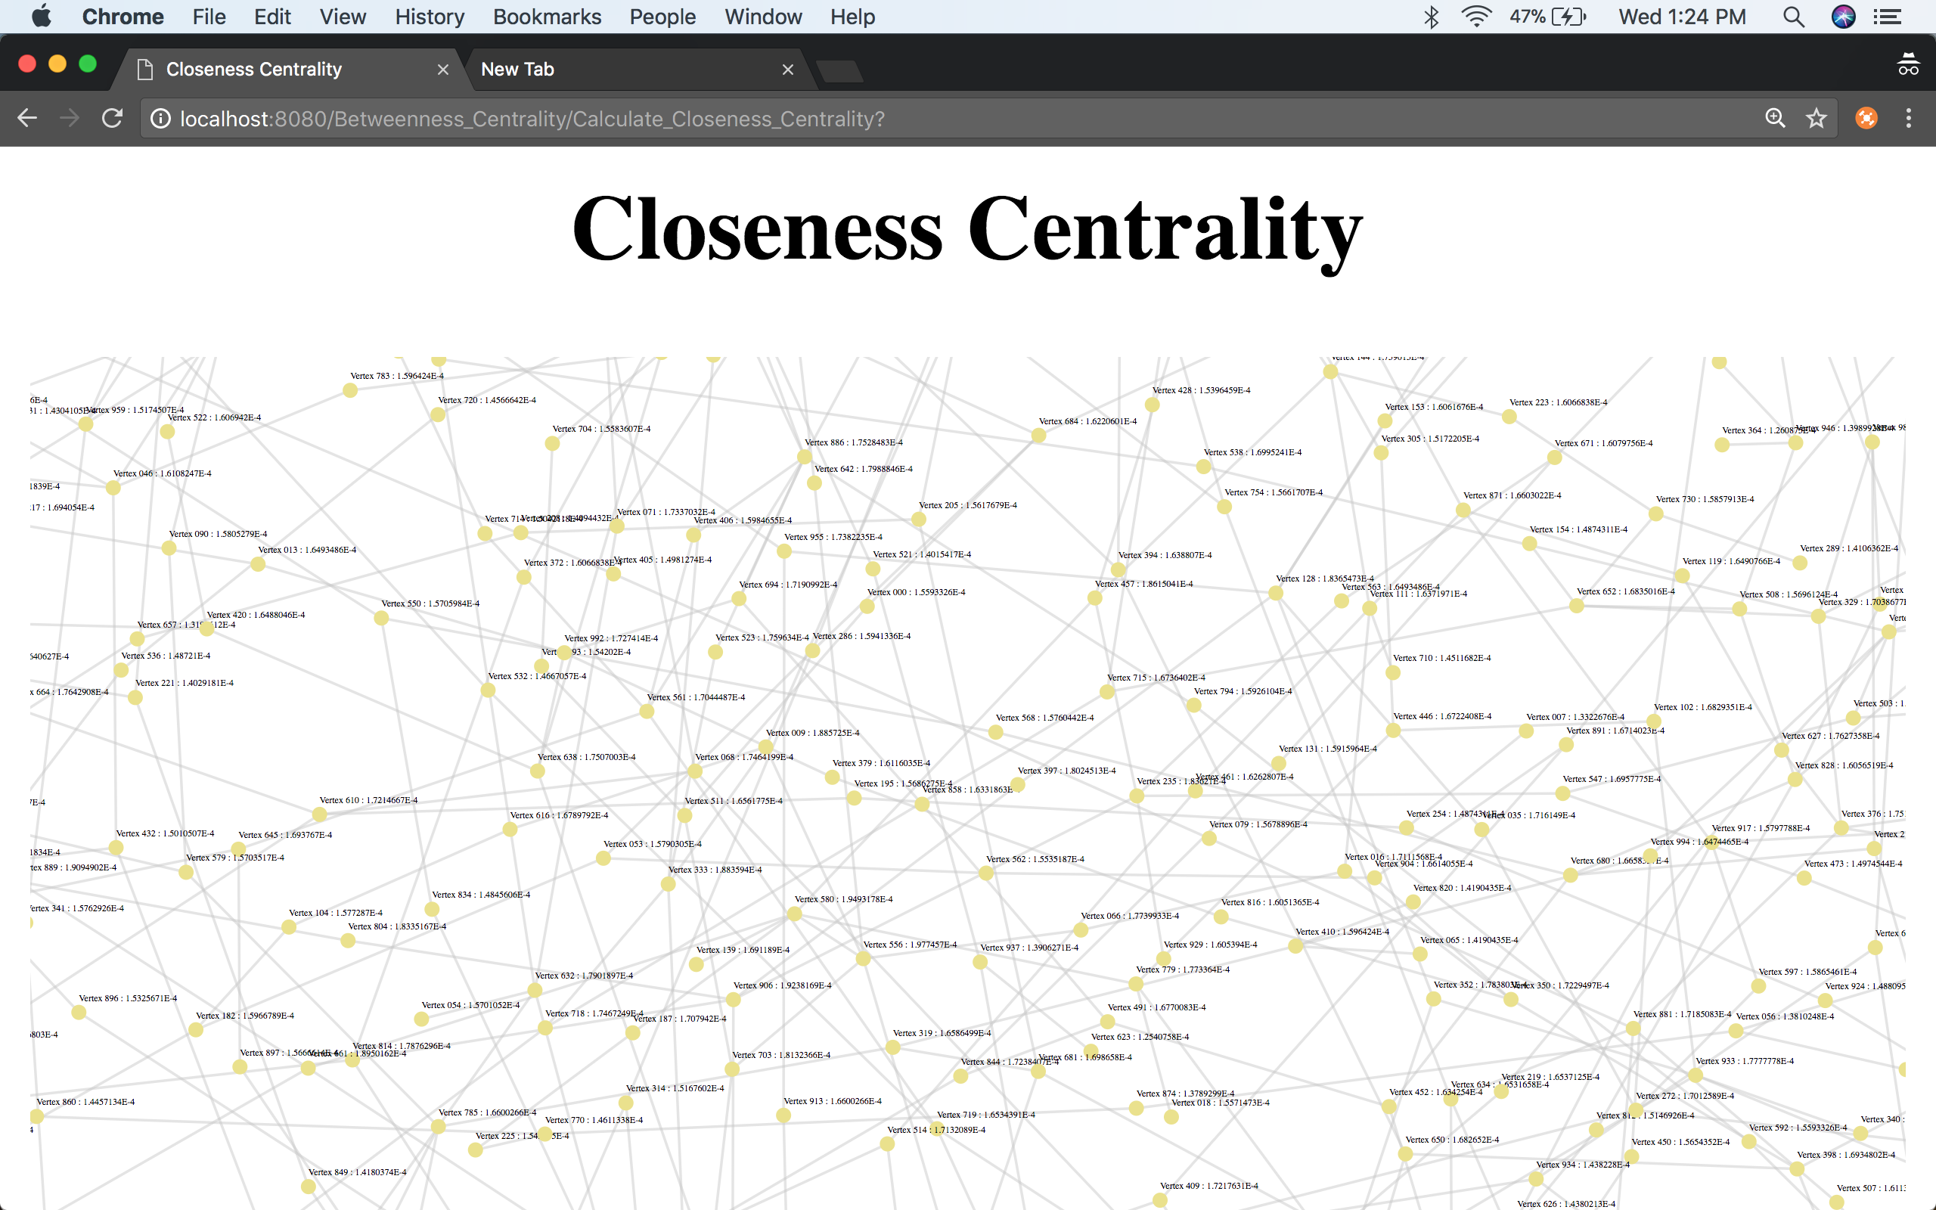

Katz Centrality

* For 6 nodes

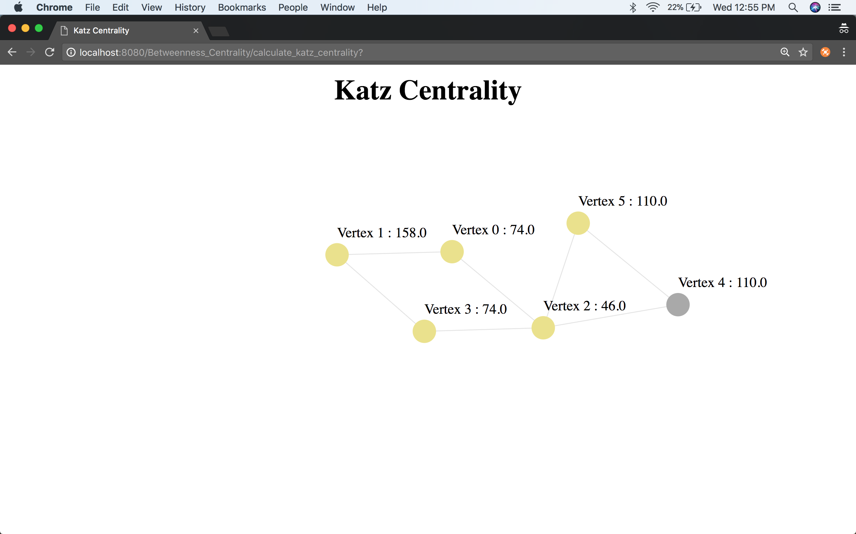

* For 880 nodes and 1000 edges

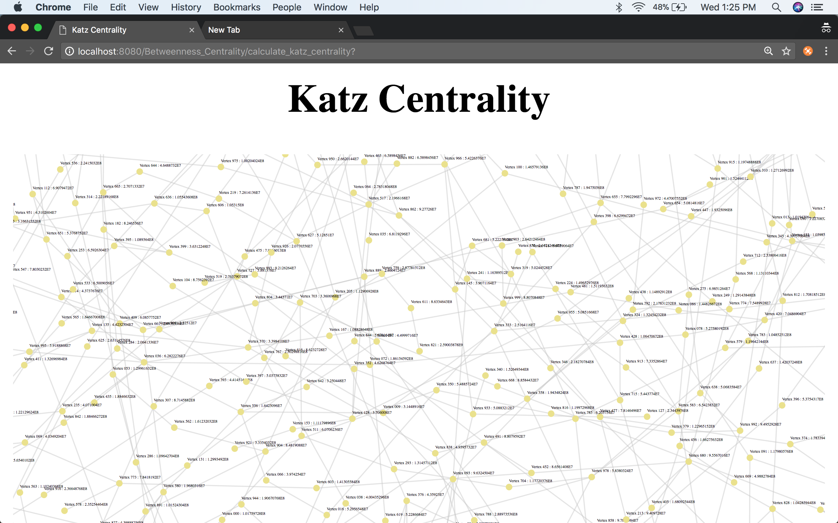

Final Centrality

For 6 nodes

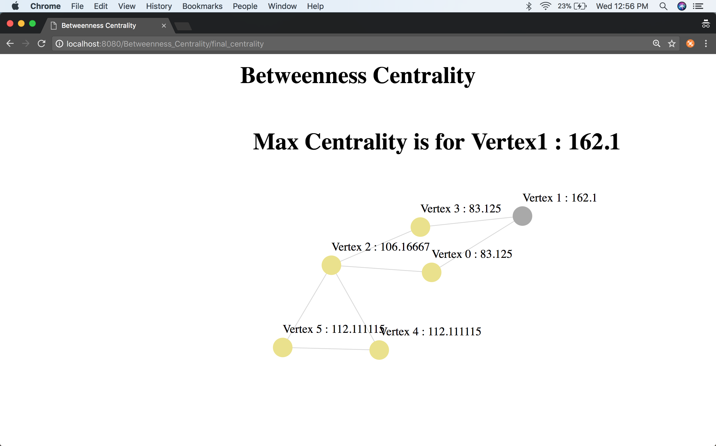

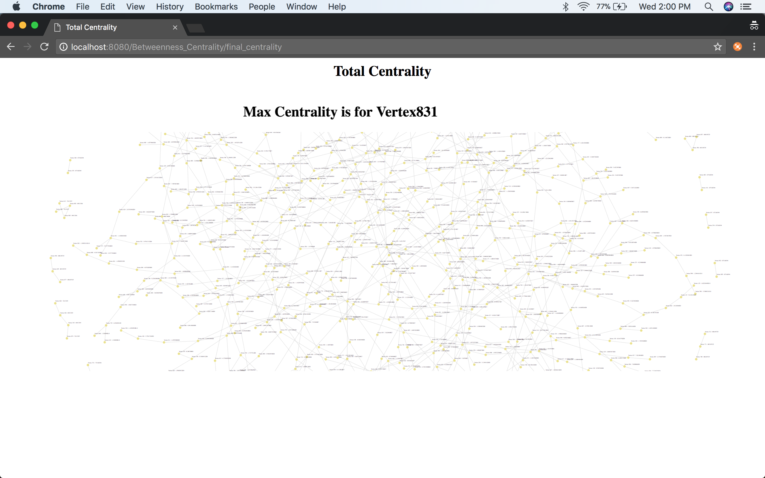

1. **Summary and Discussion**

* Centrality plays a vital role in graph analysis.
* Each centrality can be helpful only for a particular application. For example, Indegree of Degree Centrality can be helpful to gauge the most popular person whereas outdegree will be useful to gauge the gregariousness among group of people.
* Let’s analyze the final centrality after calculation of each centrality for the above set of examples:

1. Betweenness Centrality

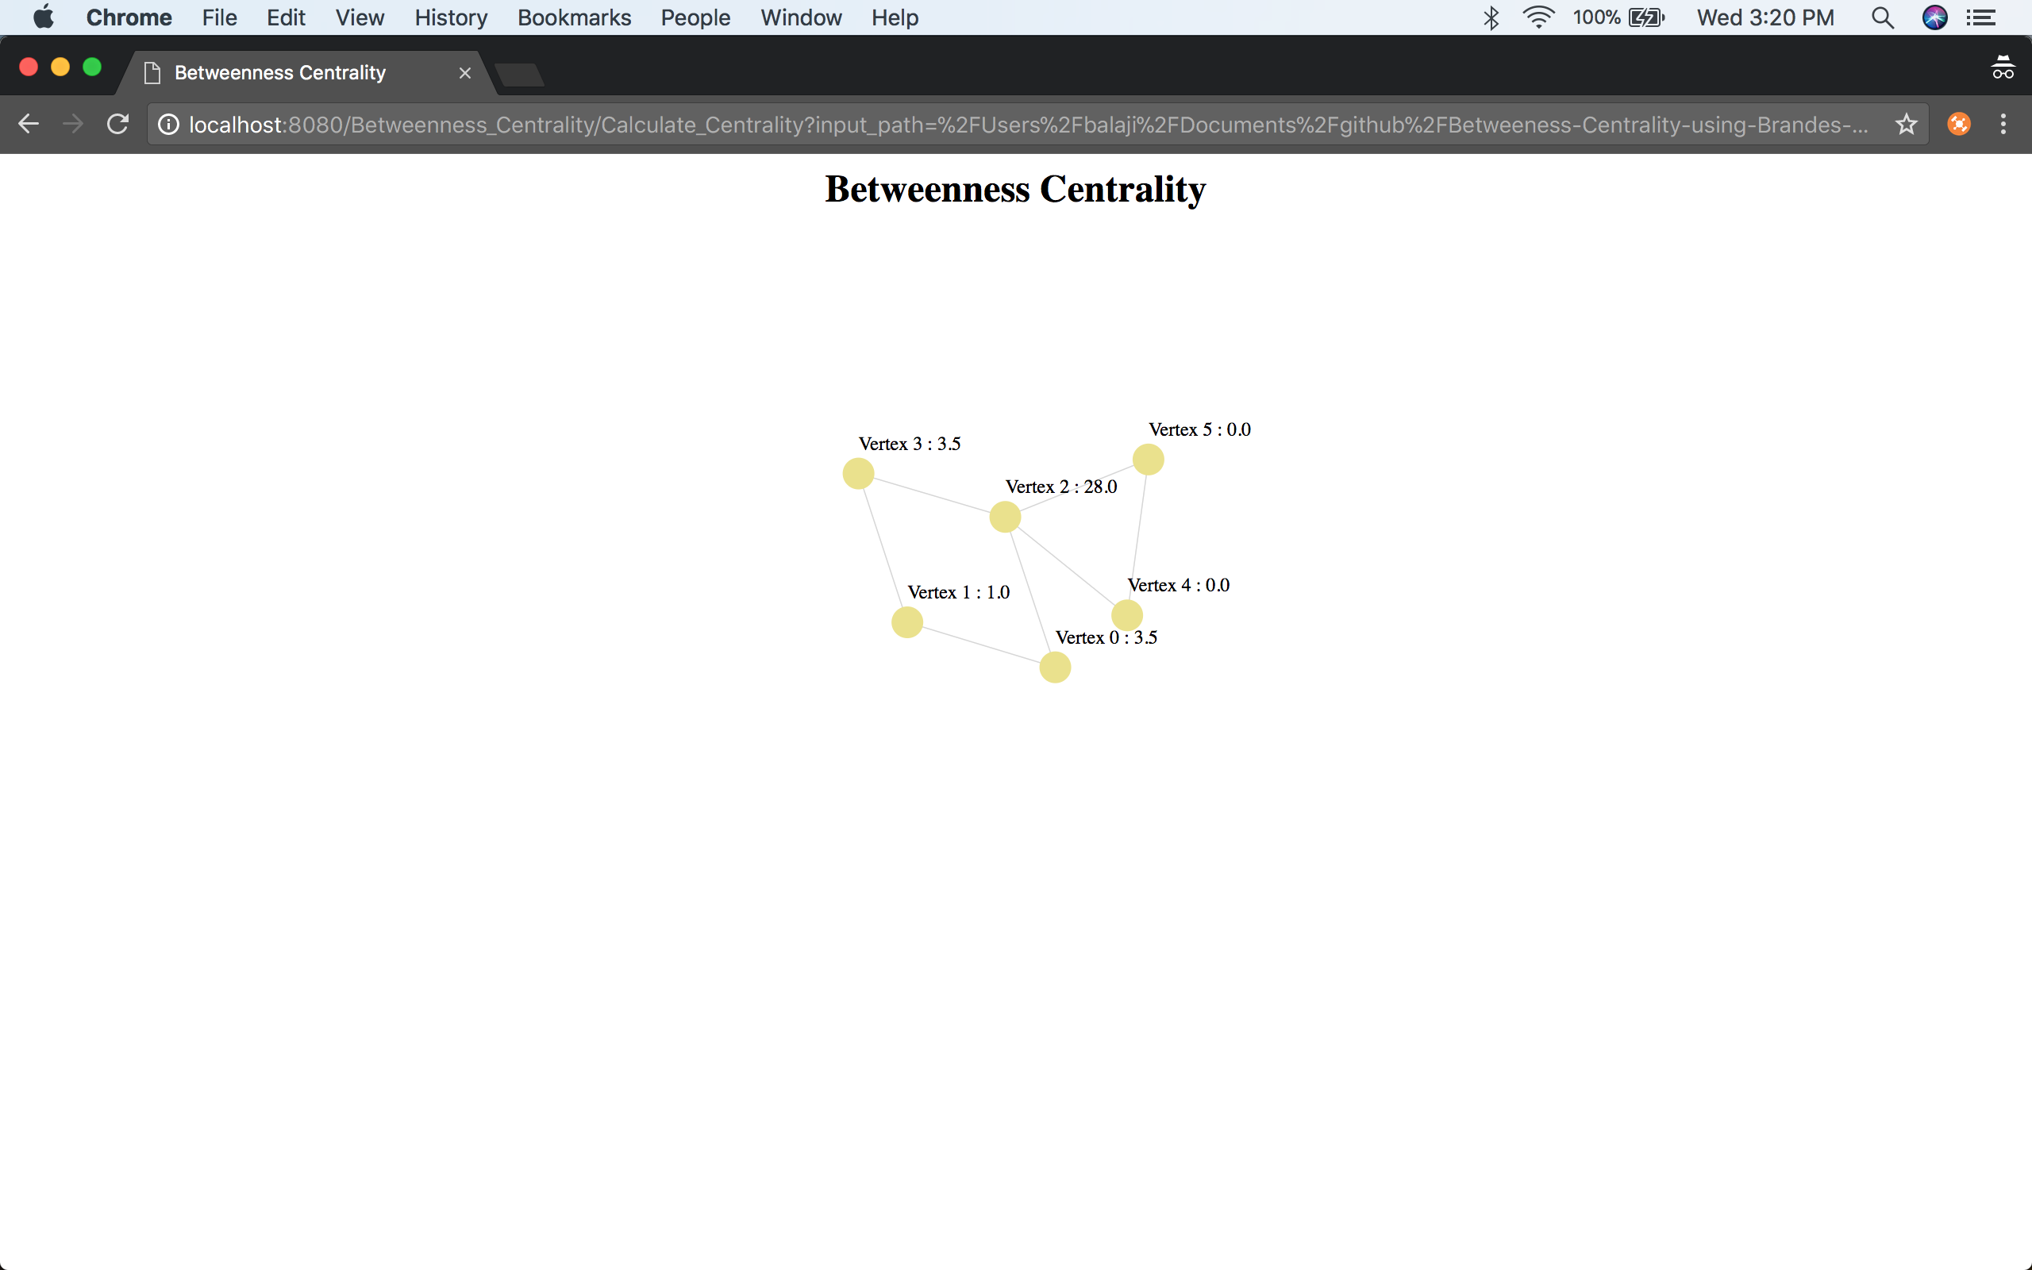

1. Degree Centrality

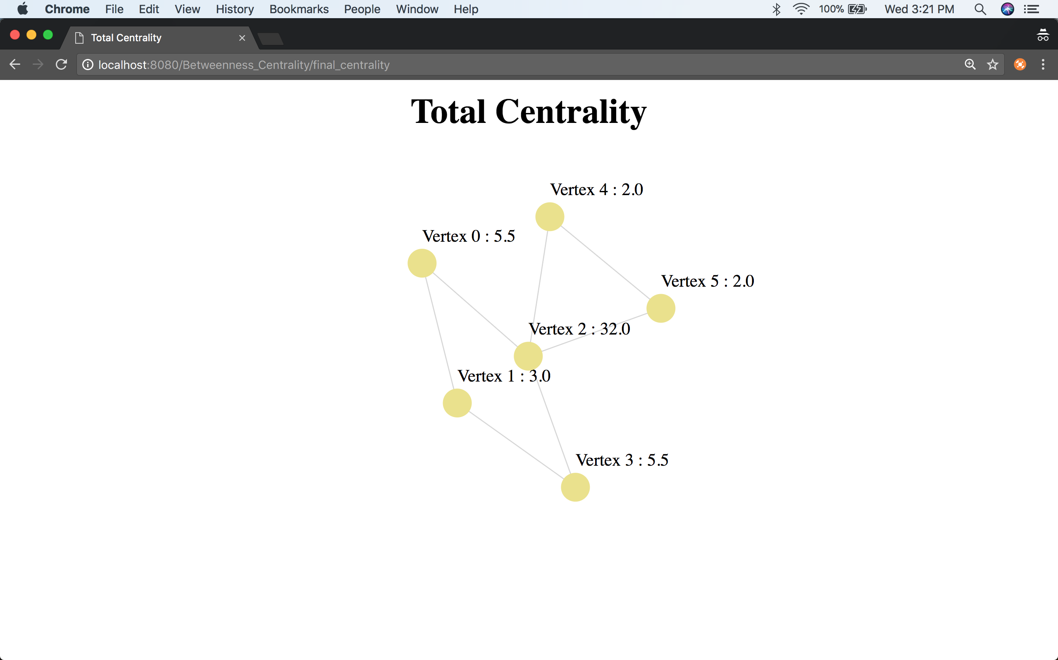

1. Closeness Centrality

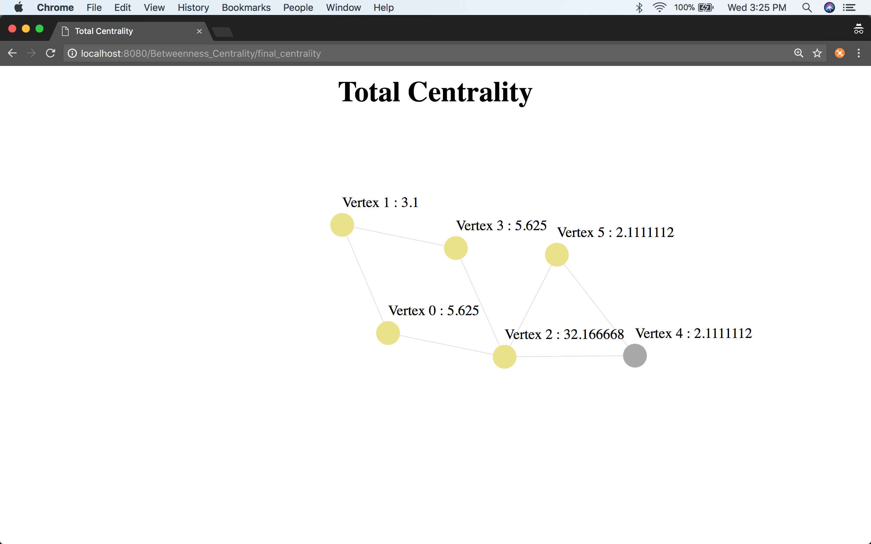

1. Katz Centrality

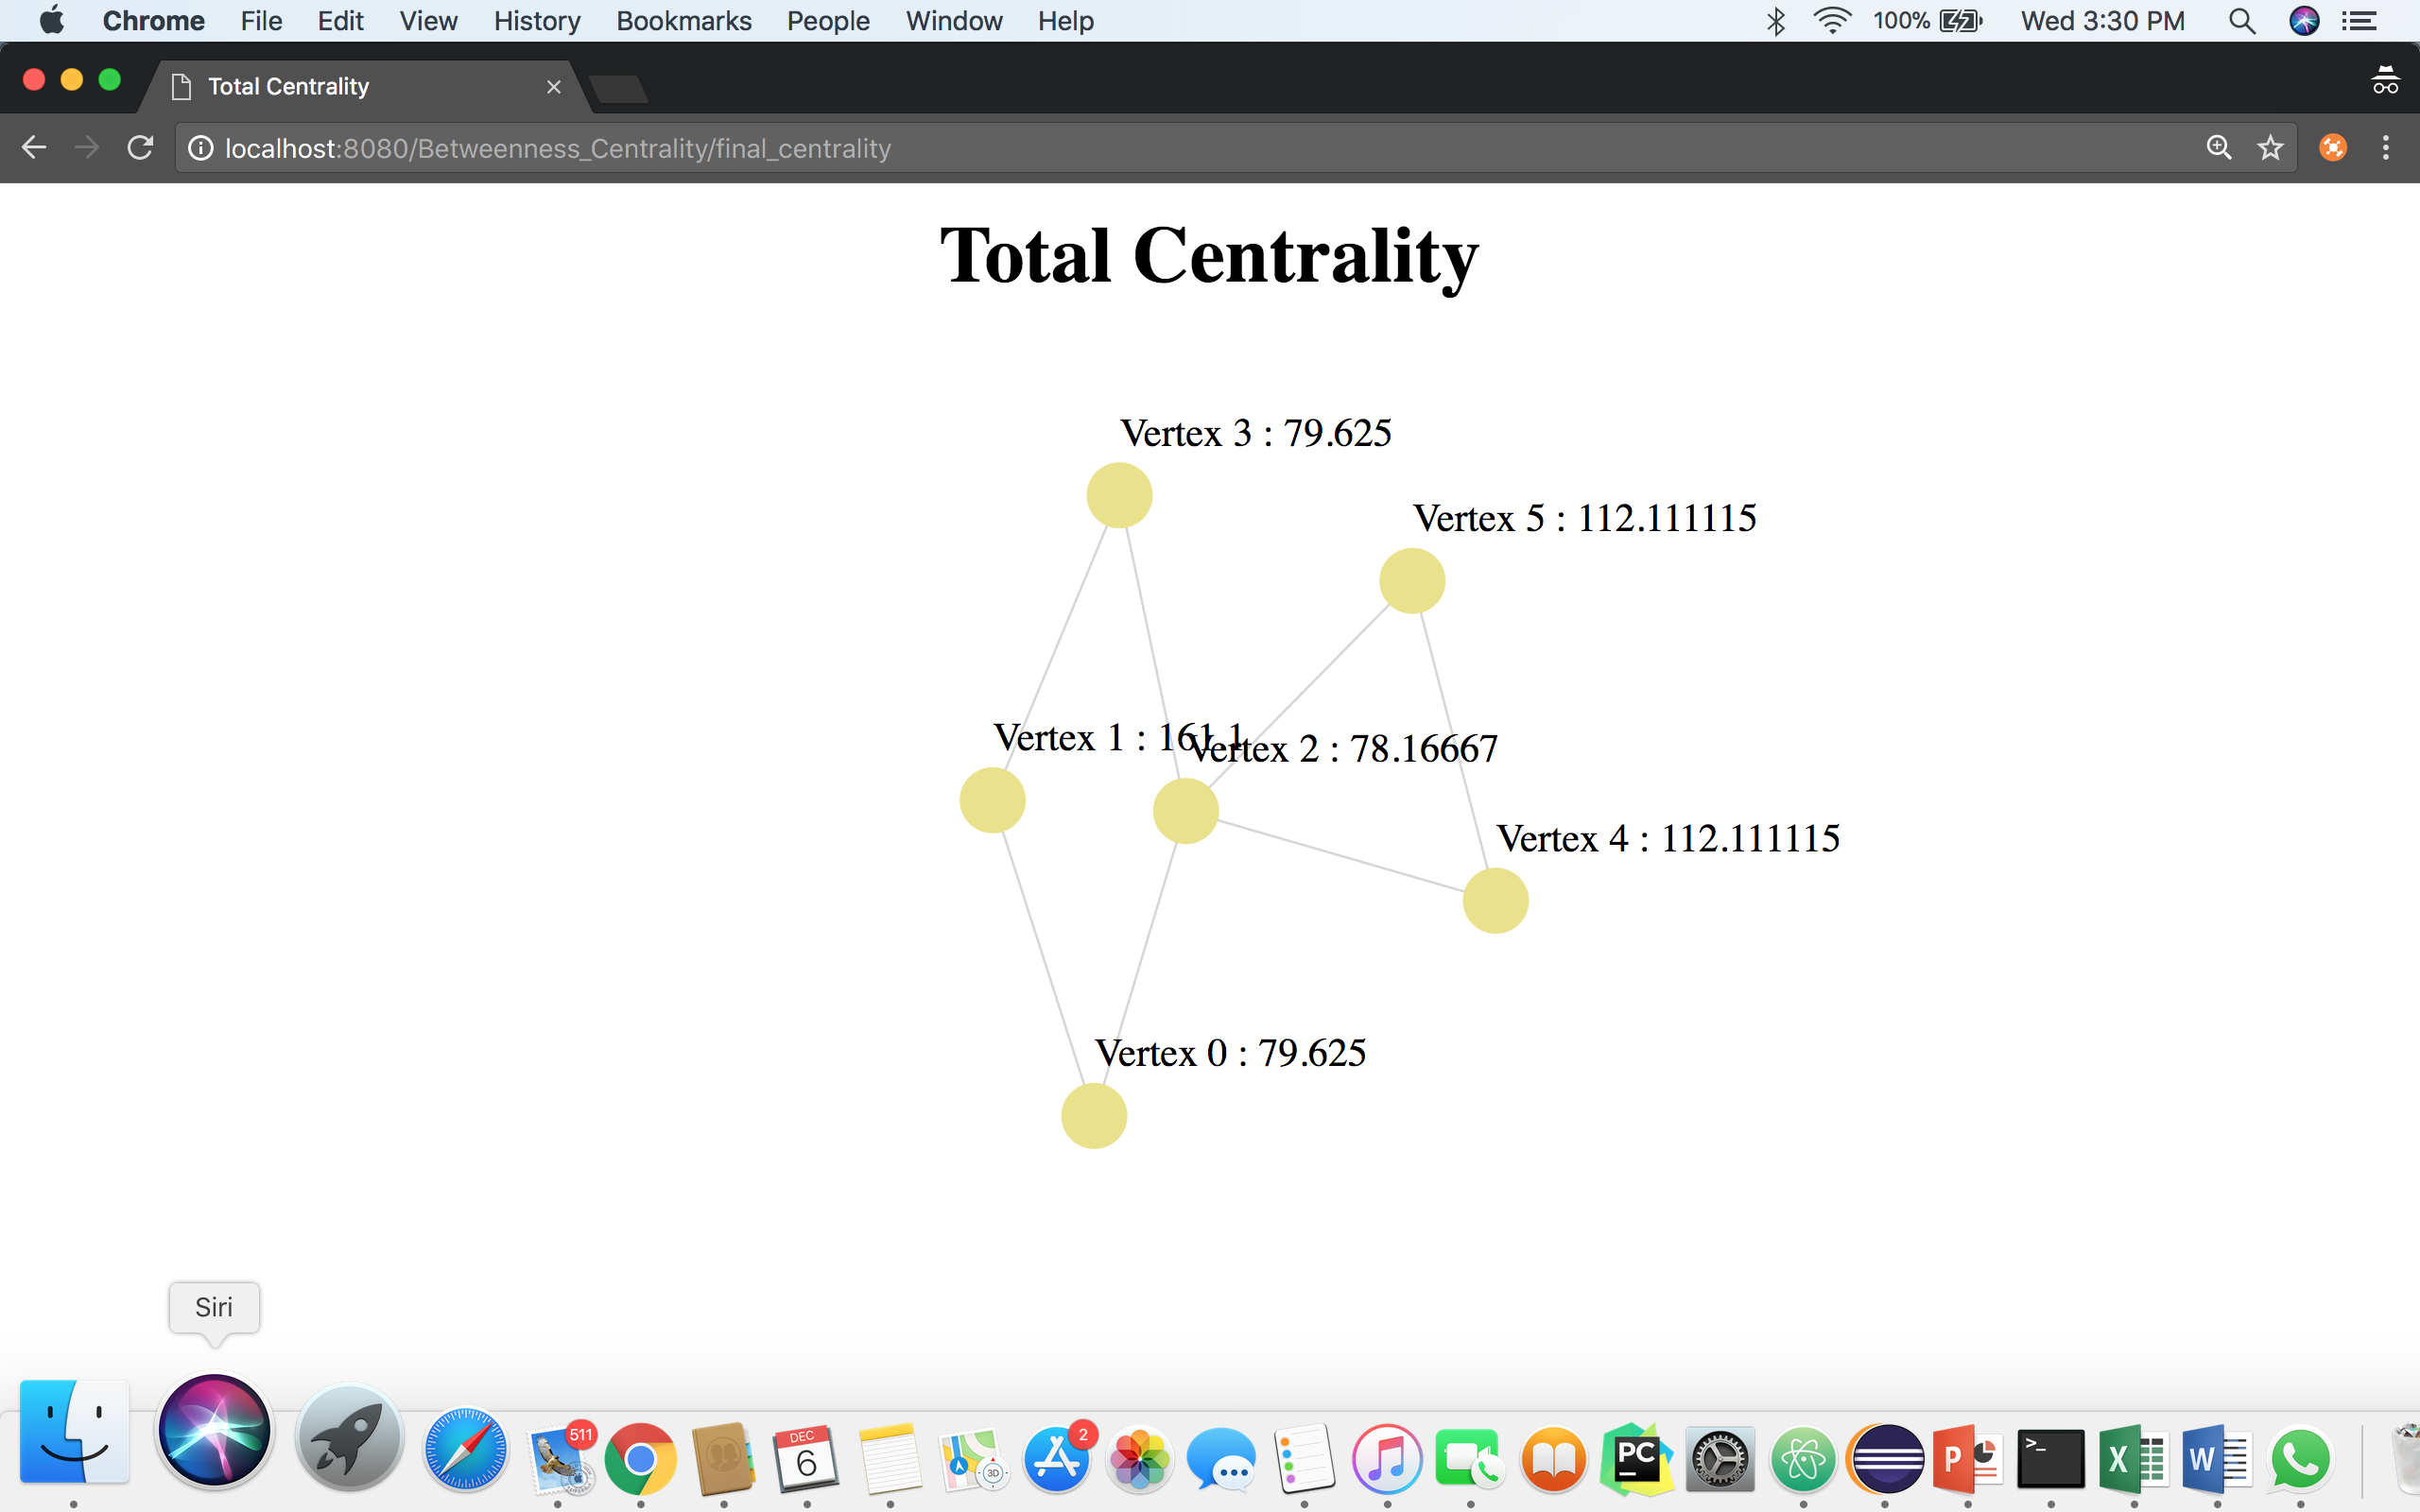

* The vertex 1 seems to have taken the lead after Katz Centrality.
* As a result, combined or the average scores of centralities cannot be considered for graph analysis.
* Time taken for calculation of centralities will be different for dense as well as sparse matrix. Also, the time will increase exponentially with the increase in the number of nodes and edges.
* So, the Brande’s algorithm has been used instead of Floyd-Warshall algorithm to calculate the Betweenness centrality. The disadvantage is that the algorithm can be used only for weightless edges. Also, negative cycles cannot be considered.
* The overall complexity for calculation of all the centralities is O(V2 log V + VE).

**References**

1. <https://en.wikipedia.org/wiki/Centrality>
2. <https://en.wikipedia.org/wiki/Closeness_centrality>
3. <https://en.wikipedia.org/wiki/Centrality#Degree_centrality>
4. <https://en.wikipedia.org/wiki/Betweenness_centrality>
5. <https://en.wikipedia.org/wiki/Katz_centrality>
6. <http://algo.uni-konstanz.de/publications/b-fabc-01.pdf>